The Great Mind Challenge, Watson Technical Edition

Watson is built on three main capabilities. The ability to interpret and understand natural language and human speech, the ability to evaluate data and determine the strongest hypothesis, and ability to adapt and learn from user responses and new information. Watson uses machine learning to help generate the most confident hypothesis by ranking hundreds of potential answers from its databases. Machine learning allows Watson to be trained on data specific to an industry or solution and then create a statistical model which it can apply to new solutions for that industry. The evidence based ranking system is at the heart of the Watson capabilities, and helps Watson deliver the most accurate results possible based on the data.

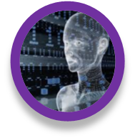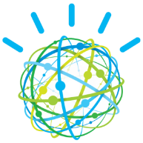
99%
60%
10%
Understands
natural language and human speech
Adapts and Learns from user selections and responses
Generates and evaluates hypothesis for better outcomes
3
2
1
…built on a massively parallel probabilistic evidence-based architecture optimized for POWER7

As the model below shows, Watson ingests data from a specific industry, and then uses its natural language processing capabilities to distill the information into a form that can be ranked later in the pipeline. Once in the Watson pipeline, different processes and algorithms establish different potential solutions based on the context of the data. The last step in the pipeline is the ranking of the solutions, where Watson analyzes all of the potential answers and uses its machine learning model to determine whether or not it is the correct one. Finally, Watson puts all of the information and solutions together and assigns a confidence rating to the solutions that are ranked the highest.

For the scope of this challenge, we will be focusing on a small piece of the “Final Merge & Rank” segment of the pipeline. In this segment, Watson uses machine learning algorithms to assign TRUE/FALSE labels to question/answer pairs that have been broken down into feature vectors, or series of numbers that represent the data of the question/answer pairs. Watson analyzes the feature vectors of a potential answer and assigns a TRUE if it believes the answer is correct, and a FALSE if it believes the answer is incorrect. The Great Mind Challenge: Watson Technical Edition will focus on the creation of a machine learning algorithm that can assign these TRUE/FALSE labels to a series of question/answer feature vectors from the Jeopardy “J!” archive that Watson used to train for its appearance on Jeopardy.

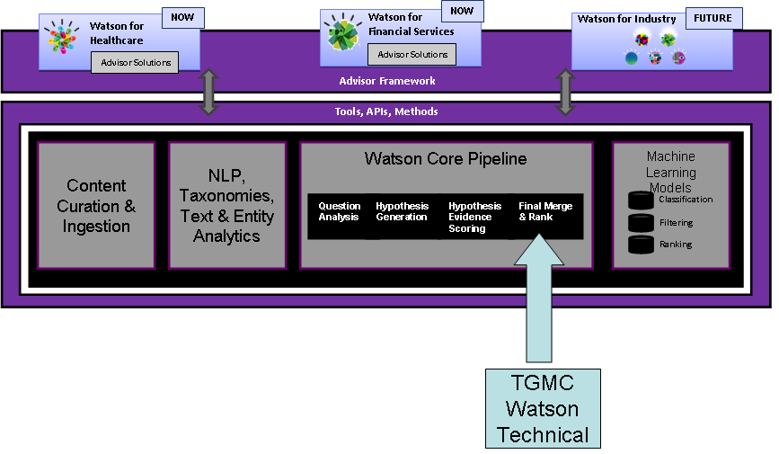
Data moves through the pipeline to become a solution
Data Sets

Watson, in many ways, is a "learning to rank" system (http://en.wikipedia.org/wiki/Learning_to_rank). For each question that Watson answers many possible answers are generated using standard information retrieval techniques. These "candidate answers" along with the corresponding question are fed to a series of "scorers" that evaluate the likelihood that the answer is a correct one. These "features" are then fed into a machine learning algorithm that learns how to appropriately weight these features.

You will receive a “training data set” from your professor of labeled data from a Watson training run. The file can be used for training and testing your Watson models. Each row in the file represents a possible answer to a question. The row contains an answer identifier, a question identifier (i.e. the question that it was a candidate answer to), the feature scores and it also contains a label indicating whether it is the right answer. The vast majority of rows in the file are for wrong answers with a smaller percentage being the correct answer.

The file is in CSV format and is a comma delimited list of feature scores. The three important "columns" in the file are the first column that contains a unique answer, the second that contains the question id (unique for every question) and the last column that contains the label. Candidate answers to the same question share a common question id, but answerids are unique for a given file. The label is true for a right answer and false for an incorrect answer. Note that some questions may not have a correct answer.

The competition will be based around three data sets. The data sets contain rows of question IDs and series of candidate answer scores for each question.

- A “Training” data set that will be used for students to build their algorithm. The training data set contains TRUE or FALSE labels for all of the questions. Students will also use the training data set to validate their algorithm. Think of the training data set as the teams’ sandbox, where they can build and test the latest version of their algorithm.

- An “Evaluation” data set that contains question/answer pairs that are NOT labeled. Students will use their algorithm to choose the correct answers in the data set and submit a .csv file containing them. IBM will maintain a list of the correct answers and will use a grading script to compare the students’ submitted answers to the correct ones.

- A “Holdback” data set, which contains question/answer pairs that are not labeled will be distributed near the end of the competition and will be the final grading data set for the students’ algorithm. Students will use their algorithm to label the final data set and submit their final .csv, which will then be graded vs. IBM’s data set to determine the winners.

Competition Prompt

The objective of the challenge is to develop an algorithm that choose correct answers in the evaluation and final data sets with the highest level of accuracy possible. All project submissions will contain answer ids for the answers that the team believes to be correct. These submissions must be in .csv format. Teams will not submit any code for their algorithm until the end of the competition, which they will submit along with their .csv for the final data set. For more information on how team submissions are graded, see the “Scoring Metric” section.

The training dataset contains candidate answers to specific questions and the candidate answers’ scores across a number of machine learning feature vectors. A feature vector is a collection of all the features (in this case, scores of candidate answers) for a specific candidate answer. Candidate answers for the same question share the same question id. A subset of the data is labeled and a subset is not labeled. Teams train against the labeled data and predict the labels of the unlabelled data within the training set.

Teams can use any programming language or type of algorithm. Team submissions are graded based on the accuracy of predicting answers in the evaluation data set. Winners of the competition are determined at the end by scoring the students predicted correct answers against the final data set. Public leader board submissions are graded daily by IBM.

Scoring Metric

The metric used to score the algorithm is as follows.

- For every correctly identified answer the team scores one point. However every answer that is incorrectly predicted to be true by the team looses a point. There is no penalty for not predicting an answer to be true. For example, let’s say there are 100 correct answers in a dataset. A team sends in a file predicting 90 answers to be true (identifying them all by their answerid). Of the 90 the team gets 60 correct, however they have also predicted an additional 30 that are incorrect. As a result that team would have scored 60 – 30 = 30.

- Each question may not necessarily contain a correct answer. Watson initially searches for answers before scoring them. It is possible that Watson's search did NOT find the correct answer, and as such the correct answer is not available in the candidate answer set.

- Some questions may have more than one correct answer. It is sufficient to choose just one correct answer.

